IDEATION PHASE
Brainstorm & Idea Prioritization
Project: AI FAQ Assistant
Date
Team ID | SWTID-2026-3317 ___
Project Name | AI FAQ Assistant
Maximum Marks | 4 Marks

Step 1: Team Gathering, Collaboration and Select the Problem Statement
Problem Statement
Users often spend a lot of time searching for answers to frequently asked questions. The AI FAQ Assistant provides quick and relevant answers to user queries using artificial intelligence, making information access easier and faster.

Step 2: Brainstorm, Idea Listing and Grouping
The following brainstorming ideas were generated for the AI FAQ Assistant project.
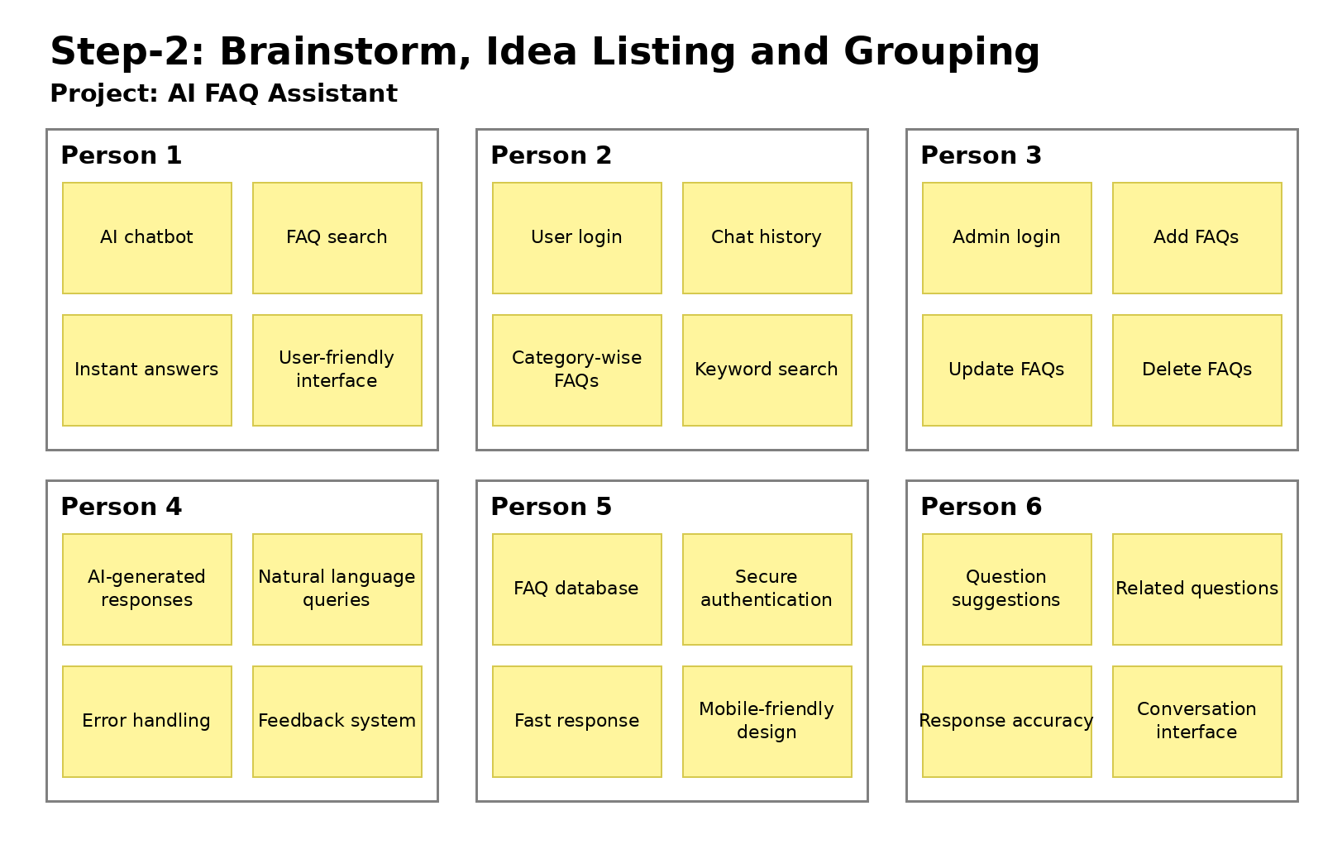

Step 3: Idea Prioritization
Ideas are prioritized according to their expected impact and practical feasibility.
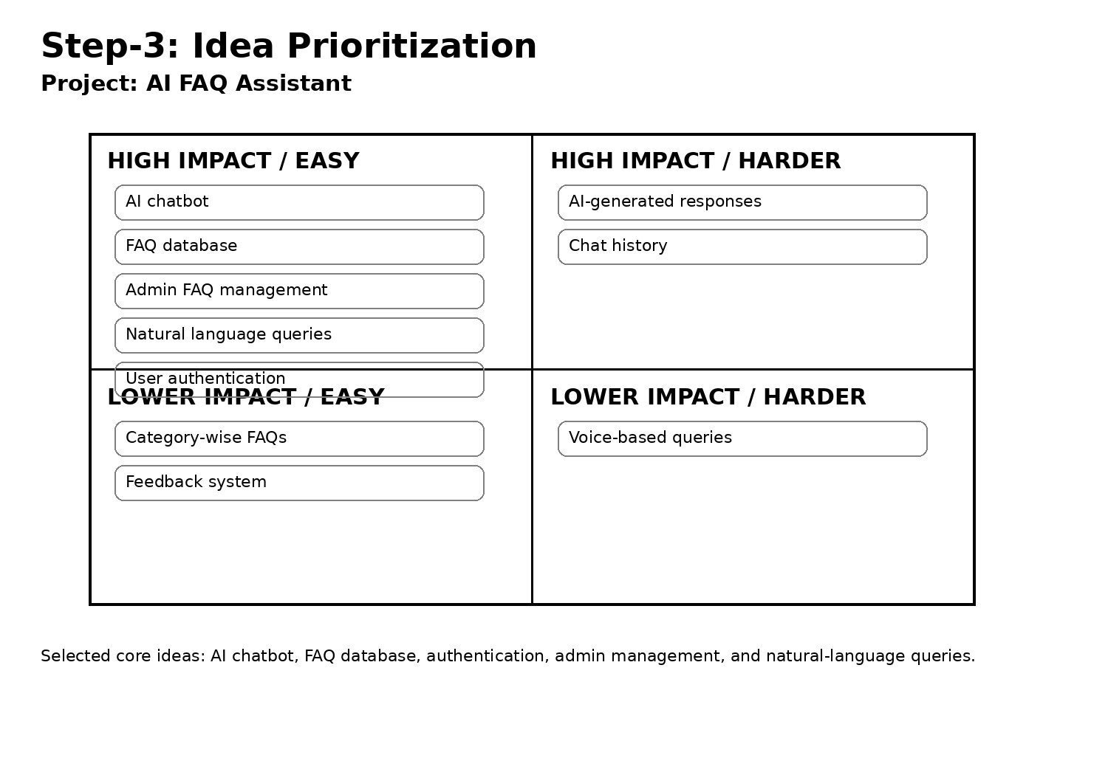

Final Selected Ideas
- AI chatbot for answering user questions
- FAQ database for storing frequently asked questions
- User authentication
- Admin management for adding, updating and deleting FAQs
- Natural-language query handling

